Suo moto disclosure under Section 4 (1)(b)

Disclosure of information under Section 4(1)(b) of the Right to Information Act, 2005 - Rolling Stock Workshop, Dahod.

(i) | The particulars of its organization, functions and duties; | 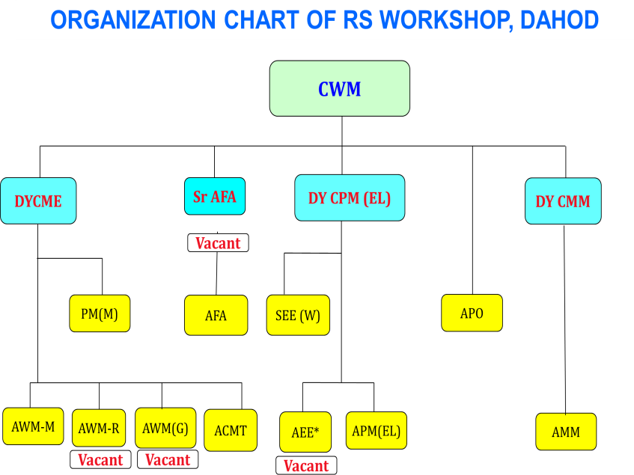
ACTIVITIES:-

- POH of Wagon, MEMU / DEMU, Loco, Tower Car
- POH+RC (Re-Cabling) of Loco.
- MTR (Mid Term Rehabilitation) of Locos.
- TOWER CAR MANUFACTURING
- REPAIR / MANUFACTURING OF WHEELS
(ii) | The powers and duties of its officers and employees; | The power and duties of its officers and employee is based on Model SOP and INDIAN RAILWAY ROLLING STOCK CODE.
(iii) | The procedure followed in the decision making process including channels of supervision and accountability; | Decision-making is based on the provisions contained in IREC, IREM, SOP, guidelines, and instructions issued by Railway Board and Head quarts. Channel of supervision and accountability is as per instructions and  rules of Indian Railways.
(iv) | The norms set by it for the discharge of its functions. | Discharge of its function is based on IREC AND IREM and SOP. https://indianrailways.gov.in/railwayboard/view_section.jsp?lang=0&id=0,5,  377
(v) | The rules, regulations, instructions, manuals and records, held by it or under its control or used by its employees for discharging its functions; | Railway Board has already issued the rules regulations, instructions manuals and records and used by the railway employees for discharging their function.  Ministry of Railways (Railway Board) (indianrailways.gov.in)
(vi) | A statement of the categories of documents that are held by it or under its control; | - Service Records of individual employees along with their personal files.  - Record of payment of salaries/incentives/allowances/Bonus etc  - Employee’s index  - Settlement documents  - Recruitment matters  - Office Orders  - Cadre positions  - Creation of staff proposals  - Files related to Transfer/Promotion/Reversion  - Selection proceedings  - APAR  - Files related to Welfare activities  - Legal matters  - Workmen compensation matters  - Pass / PTO / Duty Card Pass / Compl. Card Pass / Metal Pass / Spl.Pass  - HRMS, UMID, IPAS  - Matters related to Territorial Army  - Awards

- Grievances documents
- Files related to various Advances, like, HBA, Computer etc.
- Budget
- PCDO
- RRB Indents
- Vacancy positions
- Trade Union matters, staff associations etc.
- Reservation Rosters
(vii) | The particulars of any arrangement that exists for consultation with or representation by the members of the public in relation to the formulation of its policy or implementation thereof; | No such arrangement exists.
(viii) | A statement of the boards, councils, committees and other bodies consisting of two or more persons constituted as its part or for the purpose of its advice and as to whether meetings of those boards, councils, committees and other bodies are open to the public or the minutes of such meetings are accessible for public; | Not Applicable.
(ix) | A directory of its officers and employees; | The Directory is available at given link- Rolling Stock Workshop, Dahod
(x) | The monthly renumeration received by each of its officers and employees including the system of compensation as provided in its regulations; | All the officers and its employees are received their monthly remuneration by way of salary & allowances drawn in accordance with the pay scales authorized by the 7th Central Pay Commission.
(xi) | The budget allocated to each of its agency indicating the particulars of all plans, proposed expenditures and reports on disbursements made; | Budget grant is received from Railway Board each financial year and actual expenditure for all plan heads is dealt by Accounts Department of the Workshop.
(xii) | The manner of execution of subsidy programmes including the amounts allocated and the details of beneficiaries of such programmes; | Not applicable
(xiii) | Particulars of recipients of concessions, permits or authorizations granted by it; | Not applicable
(xiv) | Details in respect of the information available to or held by it reduced in an electronic form; | Information available at Western Railway Website Click here
(xv) | The particulars of facilities available to citizens for obtaining information including the working hours of a library or reading room, if maintained for public use; | This Workshop does not have any public library or reading room.
(xvi) | The names, designations and other particulars of the Public Information Officers; | Department- CWM Office, Rolling Stock Workshop, Freelandgunj, Dahod (Gujrat)- 389160
 |  |  | Appellate Authority | CPIO/PIO |  | APIO
 |  | Name / Shri | Binay Kumar | C.V. Rao |  | Jagdish Prasad
 |  | Gender | Male | Male |  | Male
 |  | Designation | C.W.M | Dy. C.M.E |  | A.P.O
 |  | Address | CWM Office, Rolling Stock Workshop, Freelandgunj, Dahod (Gujrat)- 389160
 |  | Phone: Rly. | 092-47600 |  | 092-47601 | 092-47609
 |  | Mobile | 9724090450 |  | 9724090452 | 9724090465
 |  | E-mail | cwmdhd@gmail.com |  | dycmedhd@gmail  .com | apowdhd@gmail  .com
(xvii) | Other Information; | Information available at Western Railway Website Click here

